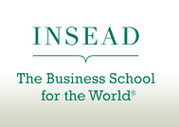

INSEAD The Business School for the World

As one of the world’s leading and largest graduate business schools, INSEAD brings together people, cultures and ideas from around the world to change lives and to transform organisations. A global perspective and cultural diversity are reflected in all aspects of our research and teaching.

With campuses in Europe (France), Asia (Singapore) and Abu Dhabi, and a research centre in Israel, INSEAD’s business education and research spans three continents. Our 145 renowned Faculty members from 36 countries inspire more than 1,000 degree participants in our MBA, Executive MBA and PhD programmes. In addition, more than 9,500 executives participate in INSEAD’s executive education programmes.

